|  |
| --- |
| Difference Between NAAC & NBA Accreditation - Haq Se EngineerPREC LONIJai Shriram Engineering College (@JSREC09) / Twitter**JAI SHRIRAM ENGINEERING COLLEGE**  **TIRUPPUR – 638 660**  Approved by AICTE, New Delhi & Affiliated to Anna University, Chennai  Recognized by UGC & Accredited by NAACandNBA (CSE and ECE) |

**DEPARTMENT OF**

**ELECTRONICS AND COMMUNICATION ENGINEERING**

**IBM - Naan Mudhalvan**

**Internet of Things**

**Group 3**

**Phase 4 – Development Part 2**

**TITLE: AIR QUALITY MONITORING SYSTEM**

**NAME : KAVINESH KUMAR S**

**NM ID : AU711221106302**

**YEAR : III**

**Introduction:**

At present, the humans are unaware of the environmental protection and harmness that caused due to the development in the technology. Mainly, the emission that are caused by the over usage of the vehicles and the gases released from the industrial sector which heavily affects the entire atmosphere including the human’s health. Hence, the main focus of this project is to provide the awareness and affection level of the harmful gases which is very dangerous to human life.

**Existing System:**

The Present Mobile air quality monitoring only provides the data on gas level, temperature and humidity of the surroundings which makes the people to be unaware of harmful gases that endangers their life. This System is used for monitoring and controlling that are extracted from the sensors.

**Development Idea:**

Our aim is to develop a improved version of the current existing system by indicating danger levels of the harmful gases in the surroundings around the user and the user can findout the level by using the Blynk IoT where the danger levels are monitored from the extracted data that are collected from the sensor.

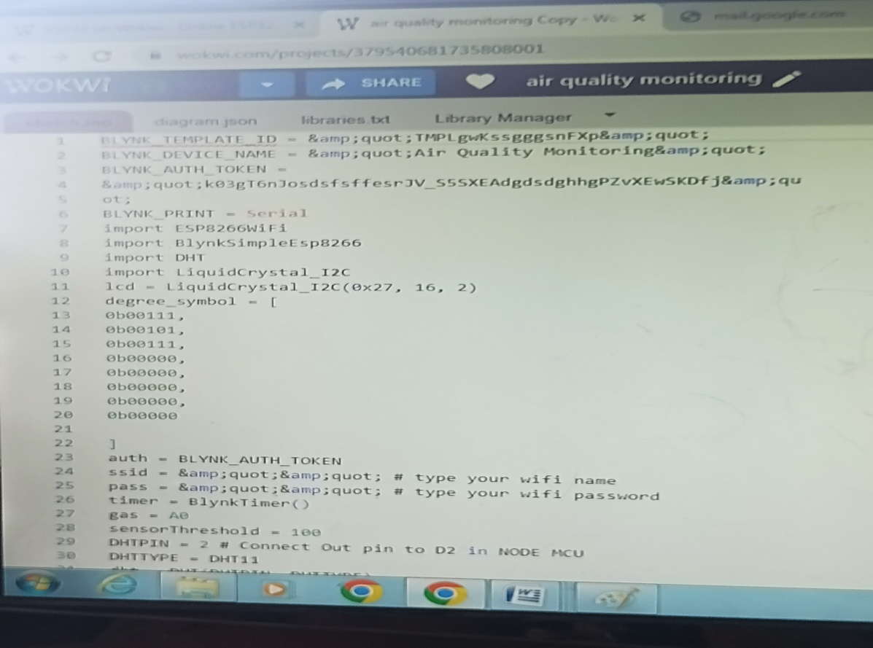

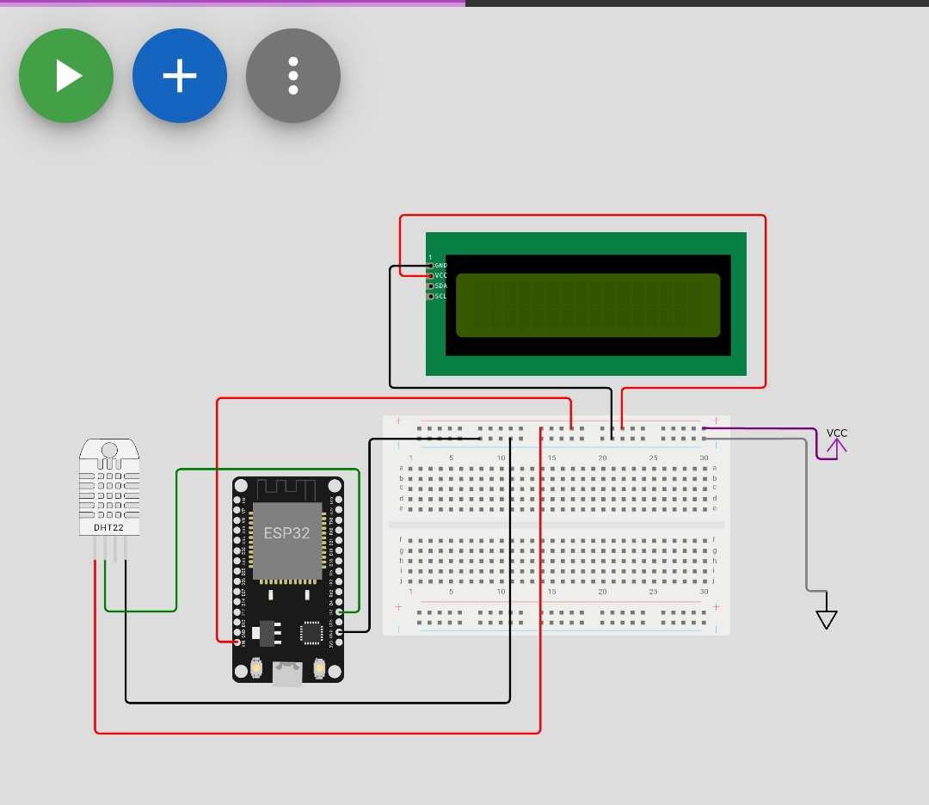

**Simulation**

**Program:**

BLYNK_TEMPLATE_ID = &quot;TMPLgwKssgggsnFXp&quot;

BLYNK_DEVICE_NAME = &quot;Air Quality Monitoring&quot;

BLYNK_AUTH_TOKEN = &quot;k03gT6nJosdsfsffesrJV_S5SXEAdgdsdghhgPZvXEwSKDfj&quot;

BLYNK_PRINT = Serial

import ESP8266WiFi

import BlynkSimpleEsp8266

import DHT

import LiquidCrystal_I2C

lcd = LiquidCrystal_I2C(0x27, 16, 2)

degree_symbol = [

0b00111,

0b00101,

0b00111,

0b00000,

0b00000,

0b00000,

0b00000,

0b00000

]

auth = BLYNK_AUTH_TOKEN

ssid = &quot;&quot; # type your wifi name

pass = &quot;&quot; # type your wifi password

timer = BlynkTimer()

gas = A0

sensorThreshold = 100

DHTPIN = 2 # Connect Out pin to D2 in NODE MCU

DHTTYPE = DHT11

dht = DHT(DHTPIN, DHTTYPE)

def sendSensor():

h = dht.readHumidity()

t = dht.readTemperature() # or dht.readTemperature(true) for Fahrenheit

if (isnan(h) or isnan(t)):

Serial.println(&quot;Failed to read from DHT sensor!&quot;)

return

analogSensor = analogRead(gas)

Blynk.virtualWrite(V2, analogSensor)

Serial.print(&quot;Gas Value: &quot;)

Serial.println(analogSensor)

# You can send any value at any time.

# Please don&#39;t send more that 10 values per second.

Blynk.virtualWrite(V0, t)

Blynk.virtualWrite(V1, h)

print(&quot;Temperature : &quot;, t)

print(&quot; Humidity : &quot;, h)

def setup():

Serial.begin(115200)

Blynk.begin(auth, ssid, pass)

dht.begin()

timer.setInterval(30000, sendSensor)

lcd.begin()

lcd.setCursor(3,0)

lcd.print(&quot;Air Quality&quot;)

lcd.setCursor(3,1)

lcd.print(&quot;Monitoring&quot;)

delay(2000)

lcd.clear()

def loop():

Blynk.run()

timer.run()

h = dht.readHumidity()

t = dht.readTemperature()

gasValue = analogRead(gas)

lcd.setCursor(0,0)

lcd.print(&quot;Temperature &quot;)

lcd.setCursor(0,1)

lcd.print(t)

lcd.setCursor(6,1)

lcd.write(1)

lcd.createChar(1, degree_symbol)

lcd.setCursor(7,1)

lcd.print(&quot;C&quot;)

delay(4000)

lcd.clear()

lcd.setCursor(0, 0)

lcd.print(&quot;Humidity &quot;)

lcd.print(h)

lcd.print(&quot;%&quot;)

delay(4000)

lcd.clear()

if gasValue &lt; 600:

lcd.setCursor(0,0)

lcd.print(&quot;Gas Value: &quot;)

lcd.print(gasValue)

lcd.setCursor(0, 1)

lcd.print(&quot;Fresh Air&quot;)

print(&quot;Fresh Air&quot;)

delay(4000)

lcd.clear()

elif gasValue &gt; 600:

cpp

lcd.setCursor(0,0)

lcd.print(gasValue)

lcd.setCursor(0, 1)

lcd.print(&quot;Bad Air&quot;)

print(&quot;Bad Air&quot;)

time.sleep(4)

lcd.clear()

if gasValue &gt; 600:

Blynk.logEvent(&quot;pollution_alert&quot;, &quot;Bad Air&quot;)